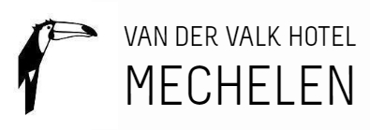

Reservation form

Dear guest,
We have the pleasure to welcome you in Van der Valk hotel Mechelen!
This reservation form must be returned by the 31-01-2023 at the latest.

Company: Zorgnet Icuro
Group code : MEC-GF5136

Guest name:………………………………………………………….

Email : …………………………………………………………………..

Arrival Date ( check-in as from 3PM): 27/04

Number of nights: 1
(extra night on request/ availability)

Departure Date ( check-out until 11AM): 28/04

Please note that rooms are reserved for the night of the 27/04/2023. Additional nights depend on availability and can be at a different rate. Please do note your required number of nights.

Room type: Depends on the availability

Rate per room per night:
27/04 : 159,€00 per room per night, including breakfast, excl 5,30€ city tax per room per night

Cancellation policy:
- Free cancellation until 15/02. After 15/02 the reservation becomes non-refundable and non-changeable.

In order to guarantee your reservation, we kindly ask you to pay in advance.
We will send you a payment link via email.
In case you should have any further questions, do not hesitate to contact us!
- 015 65 01 65
- info@hotel-mechelen.be

We look forward to welcoming you in our hotel!
Kind regards,
Team Van der Valk hotel Mechelen

** Reservations made after 31/01 will receive 12% discount on the best available rate (instead of the fixed price from above) when making use of this form.

